**Phase 4: Process Automation**

**Objective:**

Automate all aspects of leave management including validation, approvals, notifications, and updates to leave balances. This ensures efficiency, accuracy, and transparency for employees, managers, and HR.

**1. Validation Rules**

**Purpose:** Ensure correct and complete data entry when employees submit leave requests.

**Examples:**

1. **End Date cannot be before Start Date**

* Formula:

End_Date__c < Start_Date__c

* Error Message: *“End Date cannot be before Start Date.”*

1. **Leave Type must be selected**

ISBLANK(TEXT(Leave_Type__c))

* Error Message: *“Please select a Leave Type.”*

1. **Leave cannot exceed available balance** (requires Leave_Balance object)

Total_Days__c > Leave_Balance__r.Remaining_Leave__c

* Error Message: *“You do not have enough leave balance.”*

**Implementation Steps in Developer Org:**

1. Setup → Object Manager → Leave_Request → Validation Rules → New
2. Enter Name, Formula, and Error Message
3. Choose where the error appears (Field or Top of Page)
4. Save and activate

**2. Workflow Rules (Optional / Legacy)**

**Purpose:** Automate simple actions based on record changes, such as email alerts or field updates.

**Example:** Notify Manager when a leave request is submitted.

**Steps:**

1. Setup → Workflow Rules → New Rule
2. Select Object → Leave_Request
3. Evaluation Criteria → “created” or “created, and every time it’s edited”
4. Rule Criteria → Status = “Pending”
5. Add Workflow Action → Email Alert to Manager
6. Optional: Field Update → Change Status to “Pending Approval”
7. Activate Rule

Salesforce recommends **Flow Builder** instead of Workflow Rules for new projects.

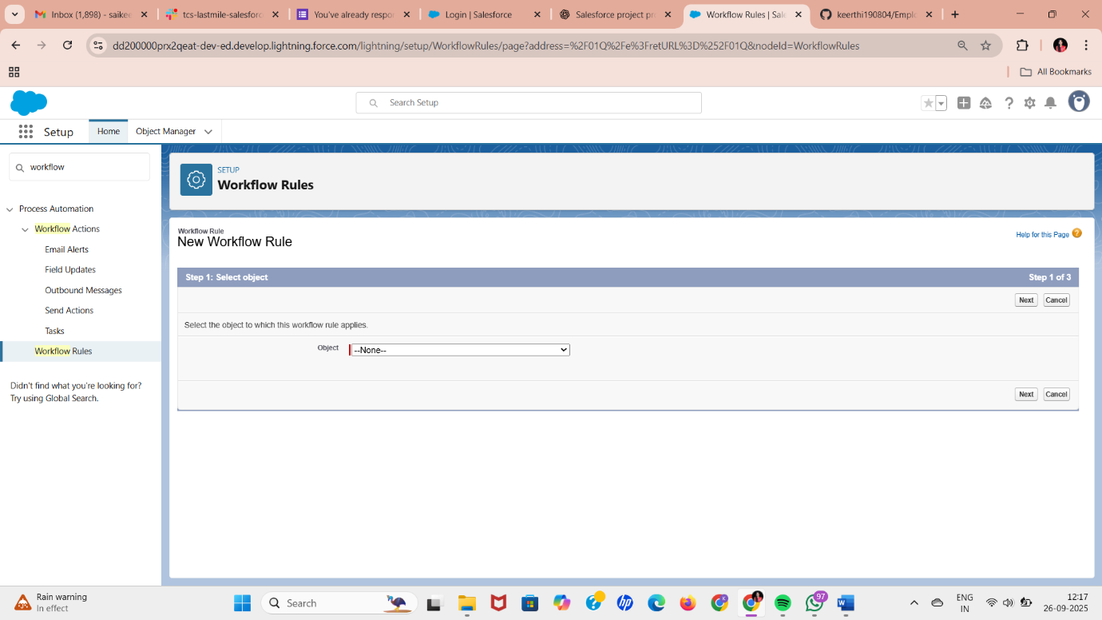

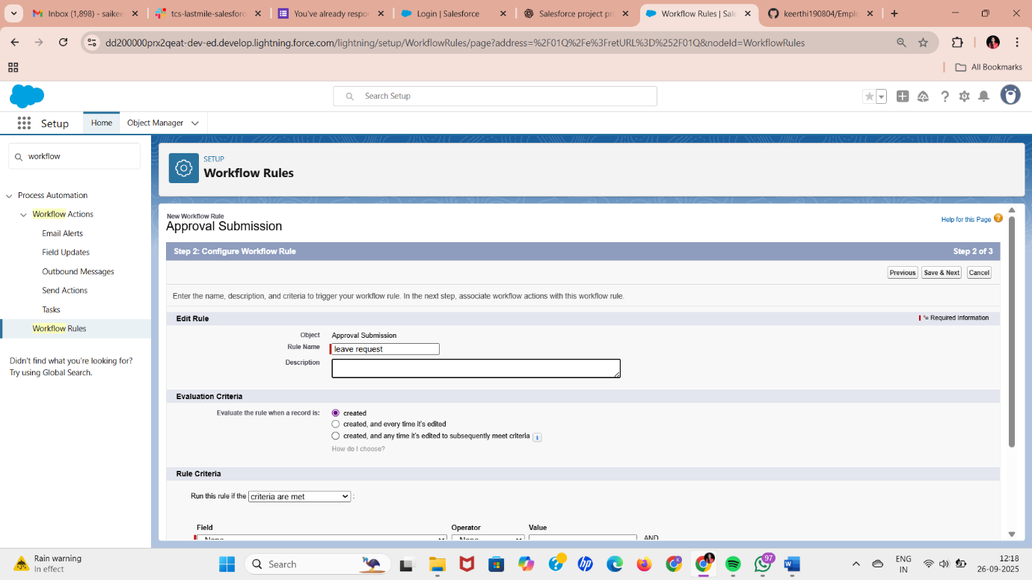

**3. Process Builder**

**Purpose:** Automate multi-step processes, like updating leave balances after approval.

**Example:** When leave is approved, automatically update the Leave_Balance object.

**Steps:**

1. Setup → Process Builder → New → Name: *“Leave Approval Automation”*
2. Object → Leave_Request
3. Start process → When a record is created or edited
4. Criteria → Status = “Approved”
5. Immediate Action → Update Related Record → Leave_Balance → Remaining_Leave__c = Remaining_Leave__c - Total_Days__c
6. Activate Process

Process Builder can also trigger email alerts or notifications.

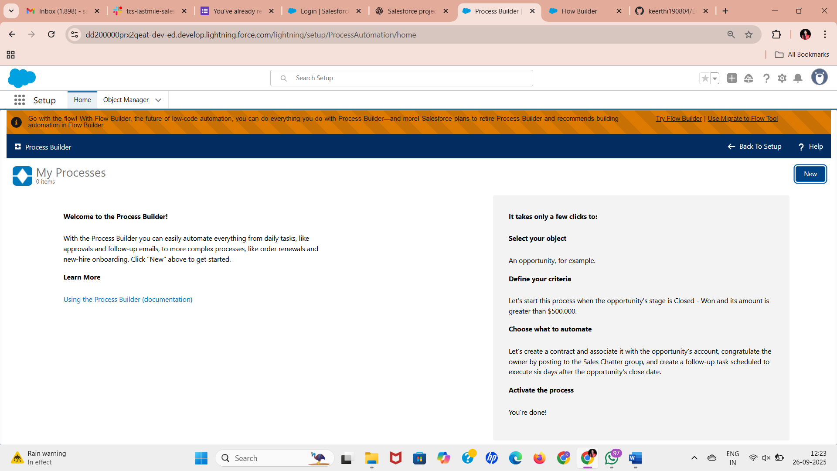

**4. Approval Process**

**Purpose:** Automate multi-level leave approvals, ensuring managers approve before HR finalizes.

**Steps:**

1. Setup → Approval Processes → New Approval Process → Use Standard Wizard
2. Object → Leave_Request
3. Entry Criteria → Status = “Pending”
4. Approver → Manager (use Hierarchical field on User object)
5. Define Actions:
   * **Initial Submission:** Email alert to manager
   * **Approval:** Update Status = Approved, update Leave_Balance
   * **Rejection:** Update Status = Rejected, send email to Employee
6. Activate the process

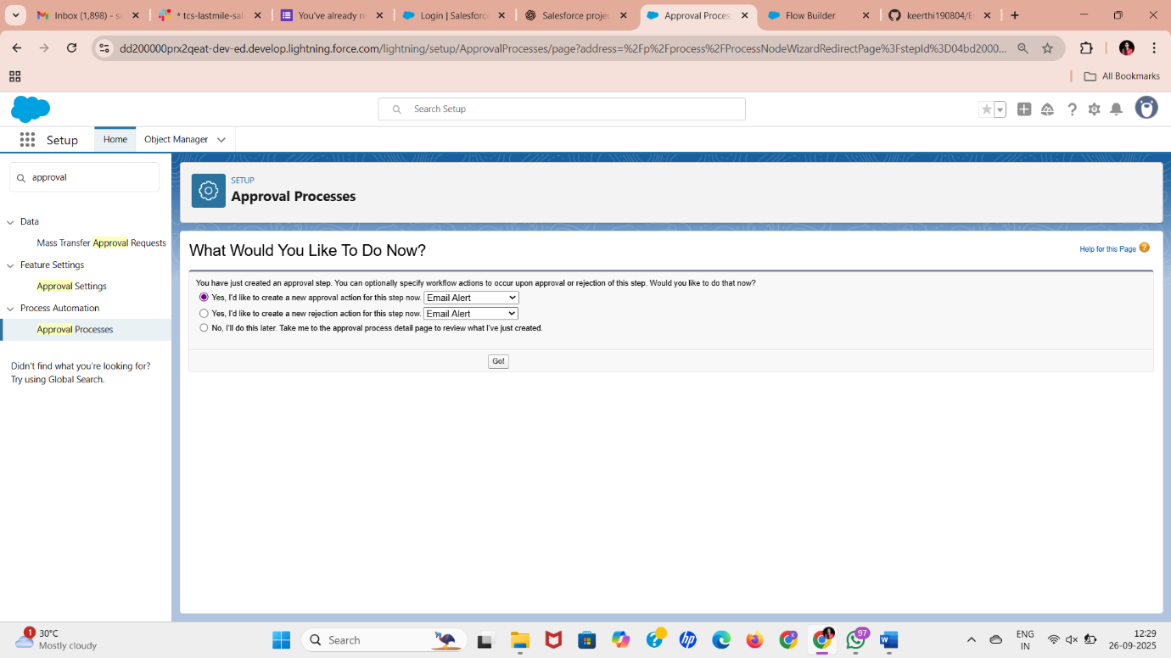

**5. Flow Builder**

**Purpose:** Automate complex or interactive processes.

**Types of Flows:**

1. **Screen Flow:** Interactive form for employees to submit leave requests
2. **Record-Triggered Flow:** Auto-update Leave_Balance when leave is approved
3. **Scheduled Flow:** Weekly reminder to managers about pending leave requests
4. **Auto-Launched Flow:** Send email or notification after status changes

**Example: Auto-update leave balance**

1. Setup → Flow → New → Record-Triggered Flow
2. Object → Leave_Request
3. Trigger → When record is updated → Status = Approved
4. Action → Update Leave_Balance → Subtract approved leave days
5. Save and Activate

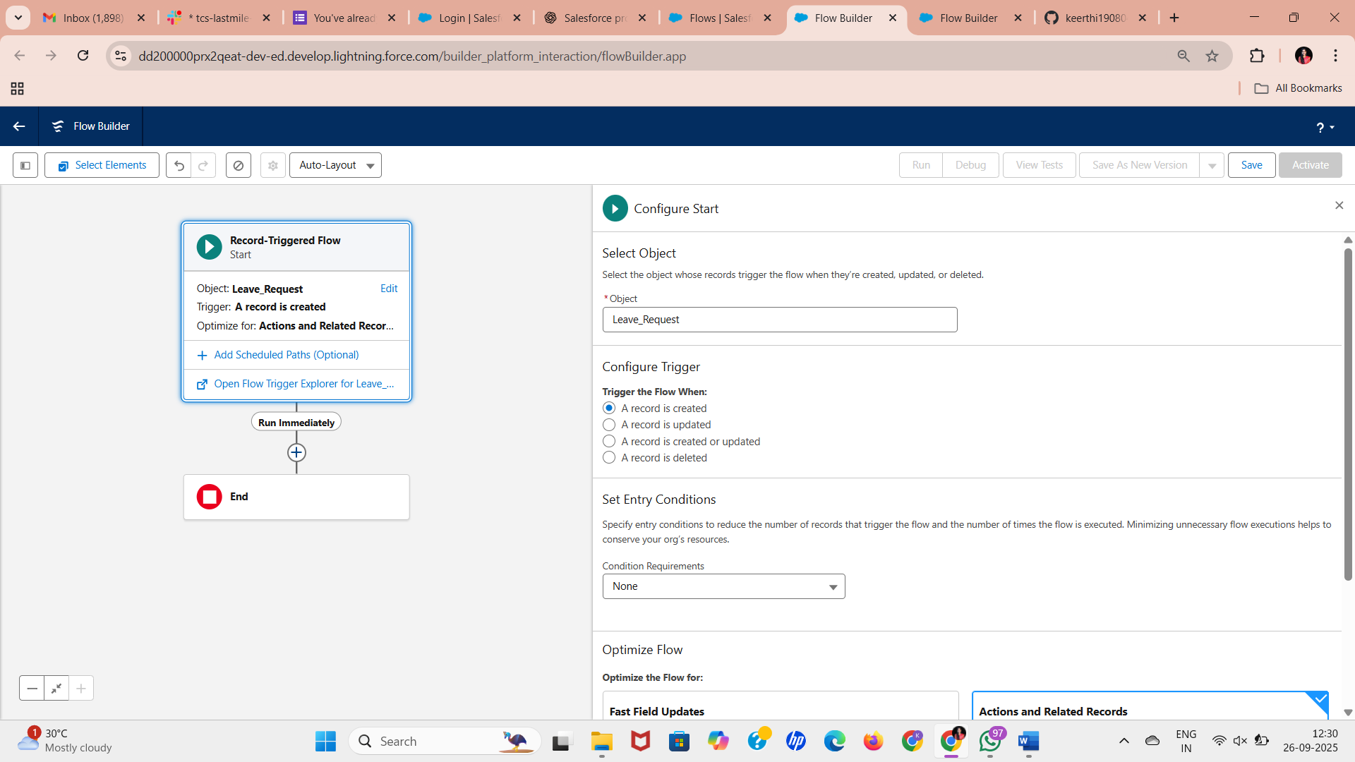

**6. Email Alerts**

**Purpose:** Notify stakeholders about leave status changes.

**Steps:**

1. Setup → Email Alerts → New
2. Object → Leave_Request
3. Add Email Template → To Manager / Employee / HR
4. Trigger via Process Builder or Flow

**Example Emails:**

* Employee → “Your leave request has been approved/rejected”
* Manager → “New leave request awaiting your approval”

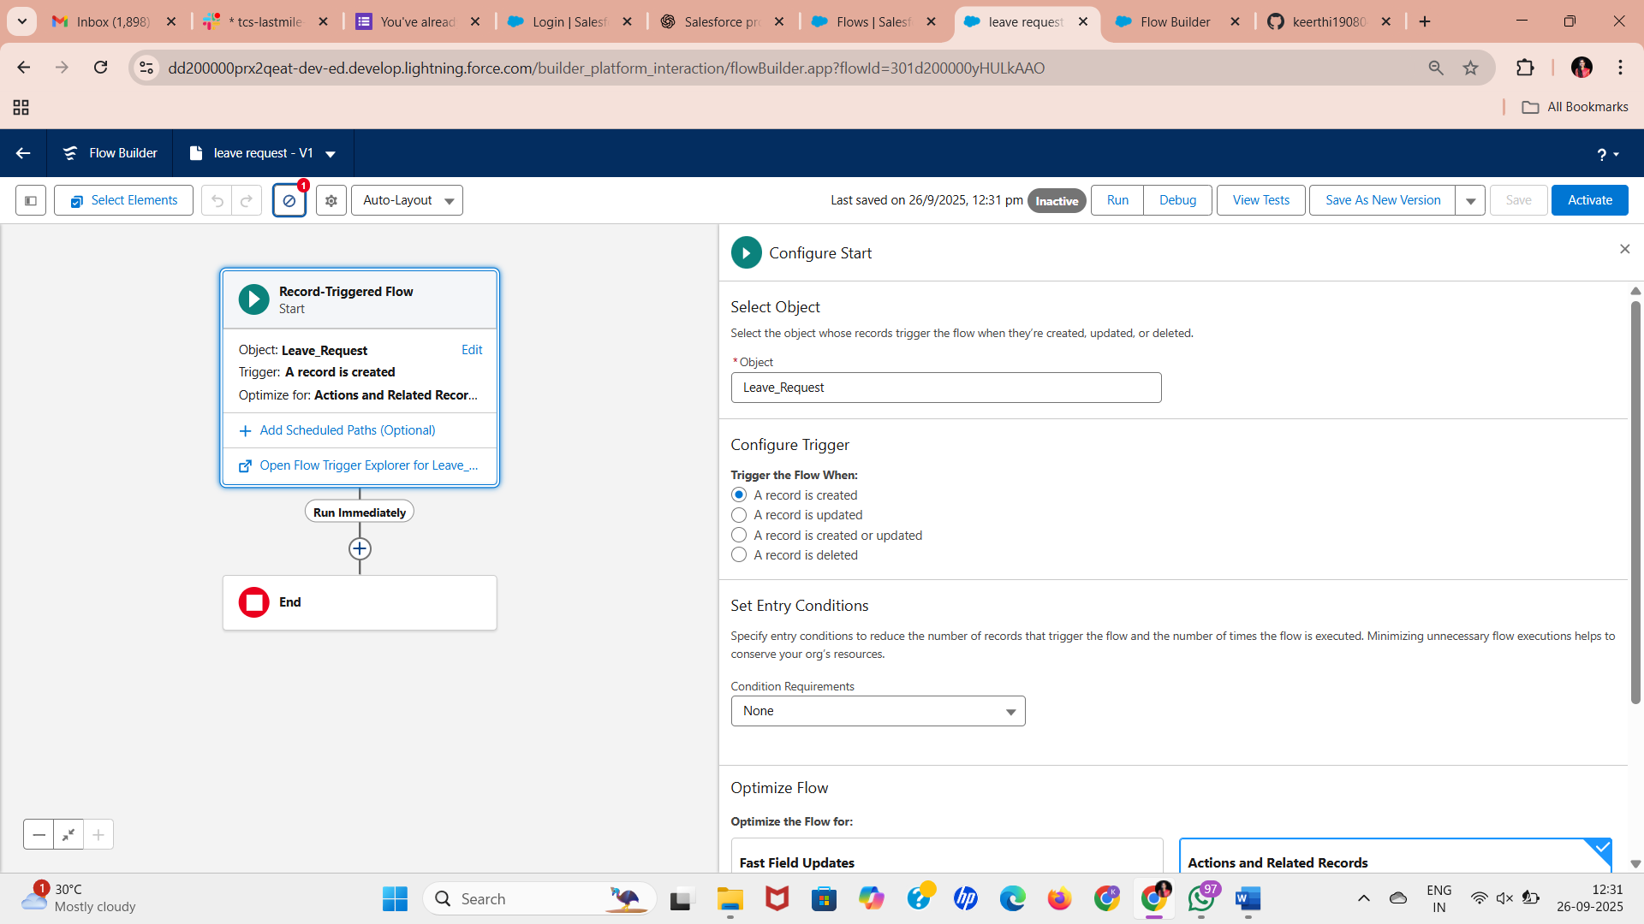

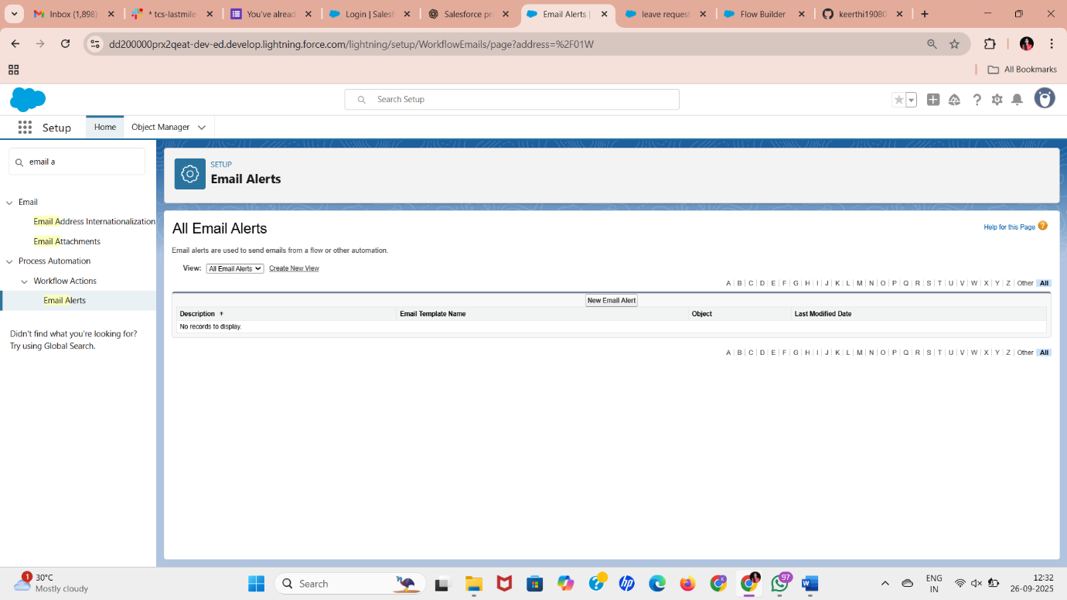

**7. Field Updates**

**Purpose:** Automatically change record values.

**Examples:**

* Status → Pending → Approved → Rejected
* Remaining Leave → Subtract approved leave

**Steps:**

* Use Flow or Process Builder → Update Record → Choose Field and Formula

**8. Tasks**

**Purpose:** Remind managers or HR to take action on leave requests.

**Implementation:**

1. Flow → Create Task → Assign to Manager
2. Subject → “Approve Leave Request”
3. Set Due Date → e.g., 2 days from submission
4. Priority → High

**9. Custom Notifications**

**Purpose:** Send in-app alerts in Salesforce Lightning to employees or managers.

**Steps:**

1. Setup → Custom Notifications → New → Name: “Leave Status Update”
2. Assign to objects (Leave_Request)
3. Trigger via Flow → When Status changes
4. Users receive notification in Salesforce app